Name: Mushtaque Ali Khaskheli

Assignment: PF Lab 4

Sec: H

Task 1
Input
#include<iostream>
using namespace std;
int main ()
{
char ans;
string dep;
cout<<"\nDo you have student ID card? (Y/N)\n";
cin>>ans;
if(ans=='N' || ans=='n')
cout<<"\nYou are not allowed to enter\n";
else
{
if(ans=='Y' || ans=='y')
{
cout<<"\nWhich is you Department? (CS EE BBA EDU)\n";
cin>>dep;
if(dep=="CS")
cout<<"Go to Block 1\n\n";
else
{
if(dep=="EE")
{
cout<<"Go to Block 3\n\n";
}
else
{
if(dep=="BBA")
{
cout<<"Go to Block 2\n\n";
}
else
{
if(dep=="EDU")
{
cout<<"Go to Knowledge Center.\n\n";
}

else
{
cout<<"\nInvalid Entry.\n\n";
}
}
}
}
}
}

system("PAUSE");
return 0;
}

OUTPUT
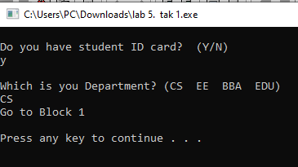

TASK 2 a.
Input
#include<iostream>
using namespace std;
int main ()
{
char choice, oper;
double num1, num2;
cout<<"Enter NO: and NO:"<<endl;
cin>>num1>>num2;
cout<<"Enter Operator (+ - * / %)"<<endl;
cin>>oper;

switch(oper)
{
case '+':
cout<<"\n(The Addition) "<<num1<<"+"<<num2<<" = "<<num1+num2<<"\n\n";
break;
case '-':
cout<<"\n (The subtraction) "<<num1<<"-"<<num2<<" = "<<num1-num2<<"\n\n";
break;
case '*':
cout<<"\n(The Product) "<<num1<<"*"<<num2<<" = "<<num1*num2<<"\n\n";
break;
case '/':
cout<<"\n(The division) "<<num1<<"/"<<num2<<" = "<<num1/num2<<"\n\n";
break;
default:
cout<<"\nInvalid Entry"<<"\n\n";

}

system("PAUSE");
return 0;
}

OUTPUT
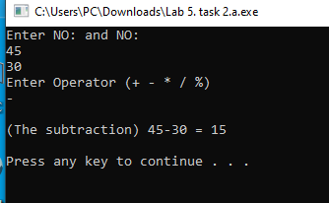

TASK 2 b.
INPUT
#include<iostream>
using namespace std;
int main()
{

int num;
cout<<"Enter month number"<<endl;
cin>>num;

switch(num)
{
case 1:
cout<<"\n\tThe 1st month is January\n\n";
break;
case 2:
cout<<"\n\tThe 2nd month is February\n\n";
break;
case 3:
cout<<"\n\tThe third month is March\n\n";
break;
case 4:
cout<<"\n\tThe fourth month is April\n\n";
break;
case 5:
cout<<"\n\tThe Fifth month is May\n\n";
break;
case 6:
cout<<"\n\tThe Sixth month is June\n\n";
break;
case 7:
cout<<"\n\tThe Seventh month is July\n\n";
break;
case 8:
cout<<"\n\tThe Eighth month is August\n\n";
break;
case 9:
cout<<"\n\tThe Ninth month is September\n\n";
break;
case 10:
cout<<"\n\tThe tenth month is October\n\n";
break;
case 11:
cout<<"\n\tThe eleventh month is November\n";
break;
case 12:
cout<<"\n\tThe Twelvith month is December\n\n";
break;
default:
cout<<"\nInvalid Entry"<<"\n\n";

}

system("PAUSE");
return 0;
}

OUTPUT
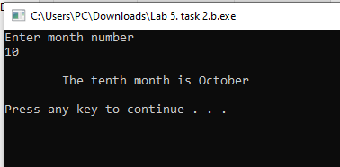

TASK 2.c
INPUT
#include<iostream>
using namespace std;
int main()
{

int num;
cout<<"Enter month number"<<endl;
cin>>num;

switch(num)
{
case 12:
case 1:
case 2:
cout<<"\nIt is a Winter season. \n\n";
break;
case 3:
case 4:
cout<<"\nIt is a Spring season. \n\n";
break;
case 5:
case 6:
case 7:
case 8:
case 9:
cout<<"\nIt is a Summer season. \n\n";
break;
case 10:
case 11:
cout<<"\nIt is a Autumn season. \n\n";
break;
default:
cout<<"\nInvalid Entry"<<"\n\n";

}

system("PAUSE");
return 0;
}
OUTPUT
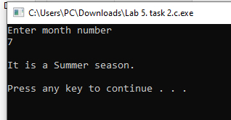

TASK 2.D
INPUT
#include<iostream>
using namespace std;
int main()
{

char letter;
cout<<"\nEnter a letter"<<endl;
cin>>letter;

switch(letter)
{
case 'a':
case 'A':
case 'E':
case 'e':
case 'I':
case 'i':
case 'O':
case 'o':
case 'U':
case 'u':
cout<<"\n\t"<<letter<<" is vowel\n\n ";
break;
case 'b':
case 'B':
case 'C':
case 'c':
case 'D':
case 'd':
case 'F':
case 'f':
case 'G':
case 'g':
case 'H':
case 'h':
case 'J':
case 'j':
case 'K':
case 'k':
case 'L':
case 'l':
case 'M':
case 'm':
case 'N':
case 'n':
case 'P':
case 'p':
case 'Q':
case 'q':
case 'R':
case 'r':
case 'S':
case 's':
case 'T':
case 't':
case 'V':
case 'v':
case 'W':
case 'w':
case 'X':
case 'x':
case 'Y':
case 'y':
case 'Z':
case 'z':
cout<<"\n\t"<<letter<<" is consonant\n\n ";
break;

default:
cout<<"\nInvalid Entry"<<"\n\n";

}

system("PAUSE");
return 0;
}

OUTPUT
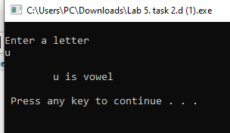

TASK 2.E
INPUT
#include<iostream>
using namespace std;
int main()
{

int num,a;
cout<<"\nEnter a number"<<endl;
cin>>num;

a=num%2;

switch (a)
{
case 0:
cout<<"\n"<<num<<" is even\n\n";
break;
case 1:
cout<<"\n"<<num<<" is odd\n\n";
break;
default:
cout<<"\nInvalid Entry"<<"\n\n";

}

system("PAUSE");
return 0;
}
OUTPUT
